Step 1: Go to your AWS console and search for EKS

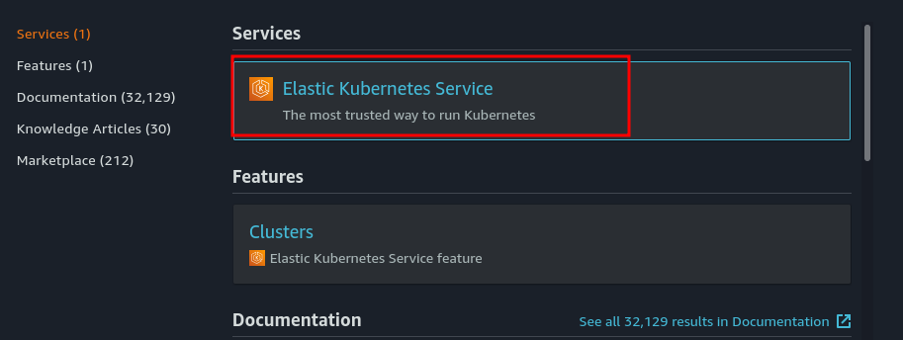

Step 2: GO to eks and click on add cluster

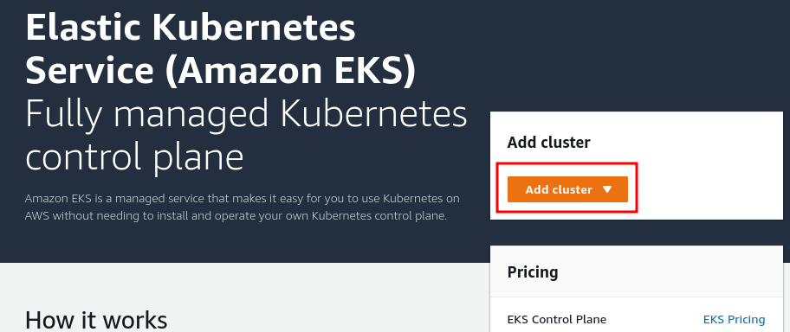

Step 3: Click on create and create the cluster

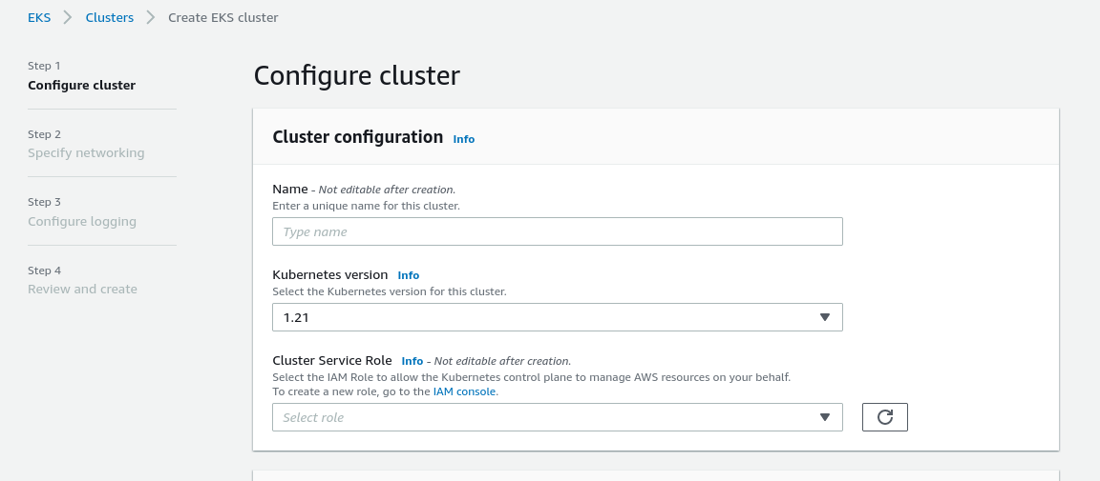

GO to IAM and create a new role with eks cluster policy

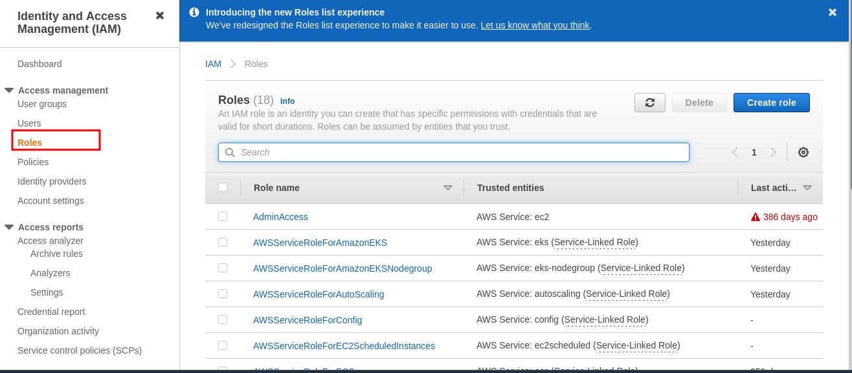

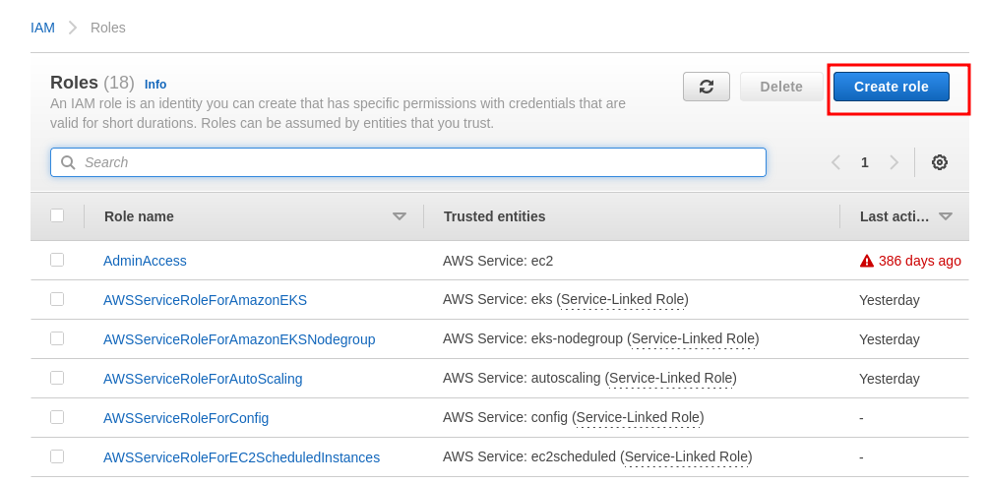

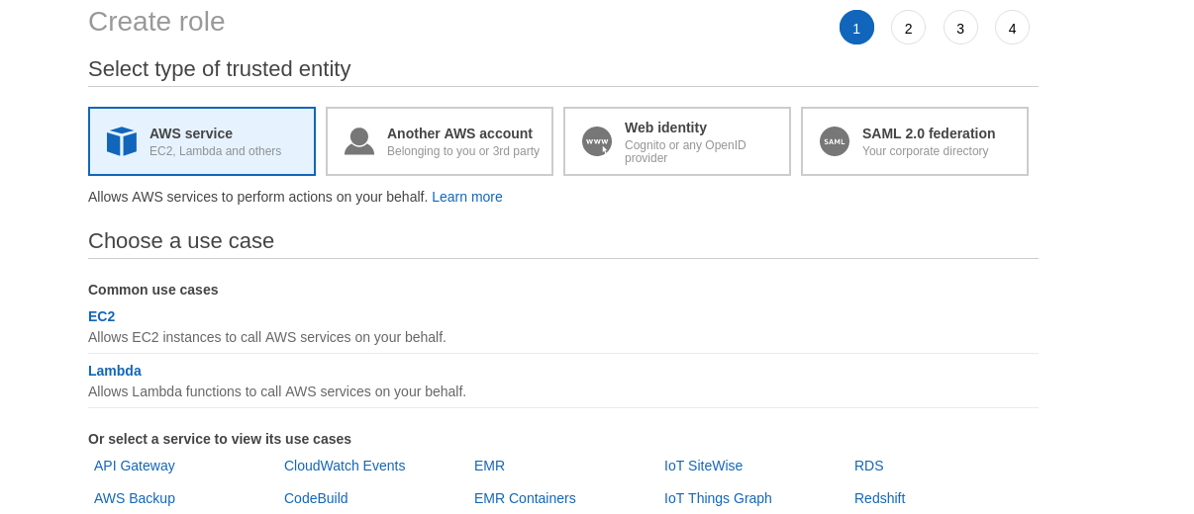

* Select EKS

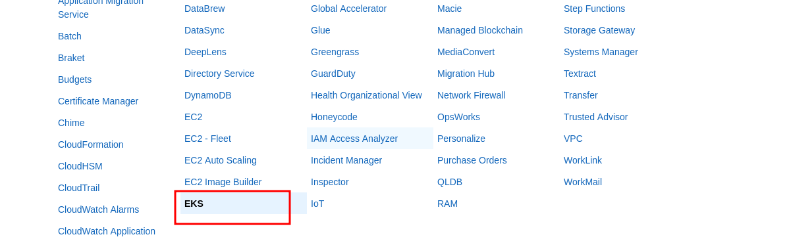

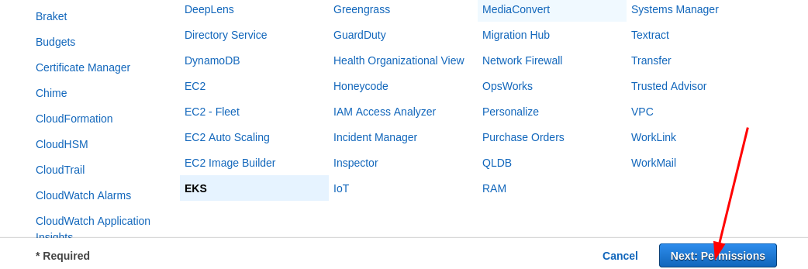

* Create the IAM role

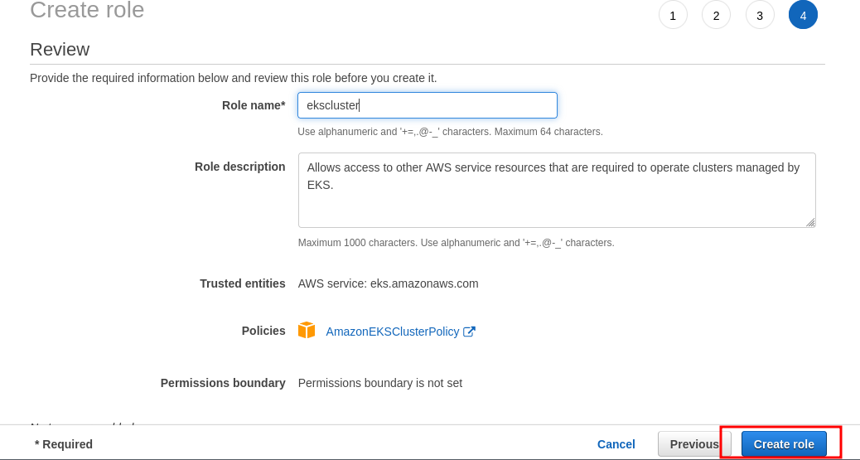

* Now go to your eks add cluster and select the role you created

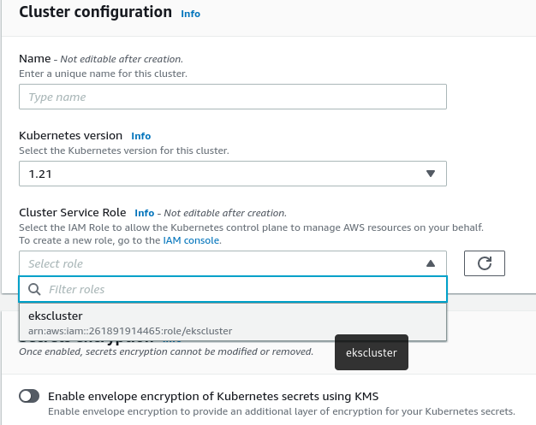

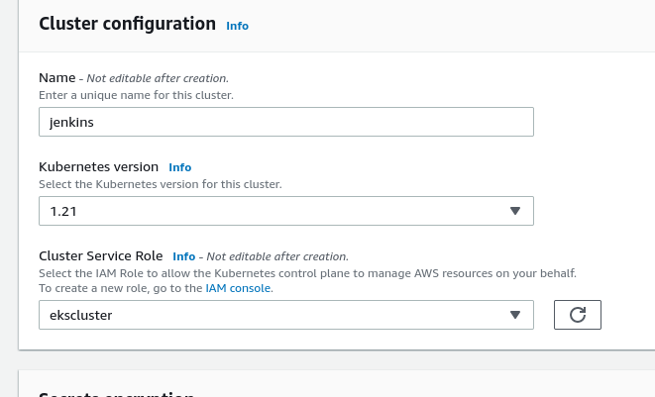

* Next and configure the security group which will be having all traffic

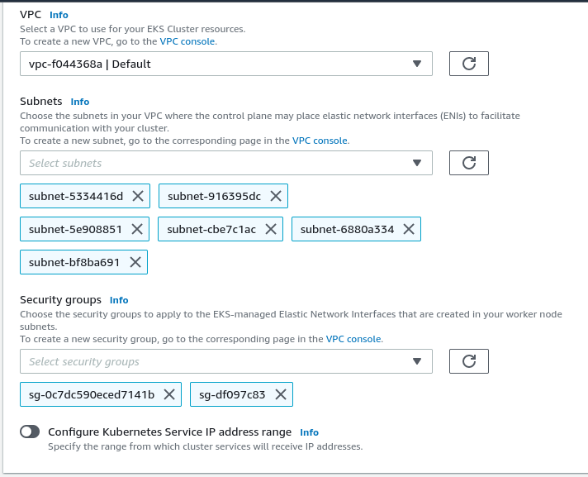

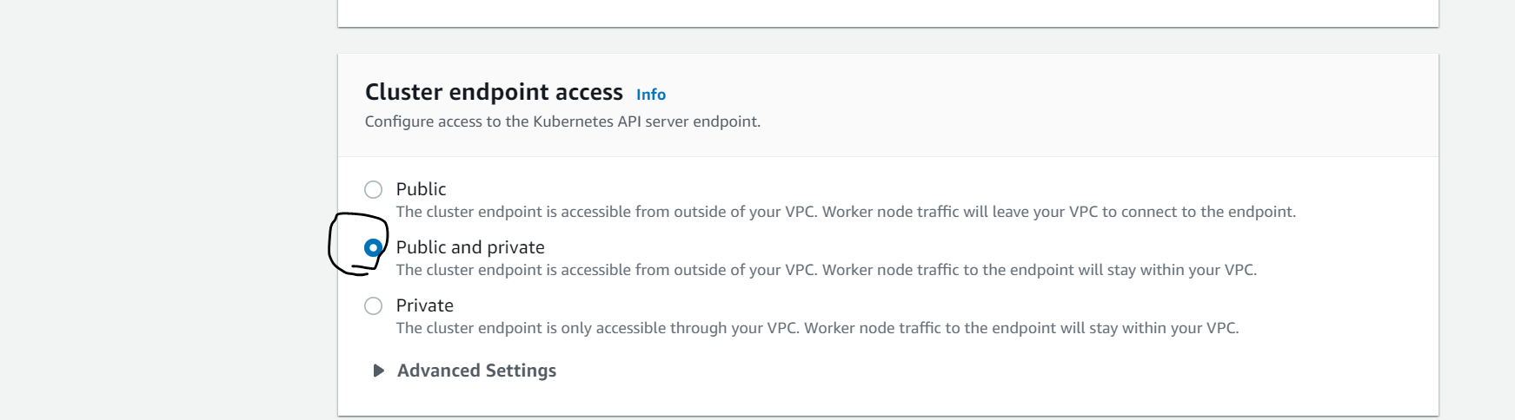

Note : By default EKS will take all the subnets which are there in the default vps that you have selected you can configure network according to your requirement

* Leave everything else on default and create the cluster

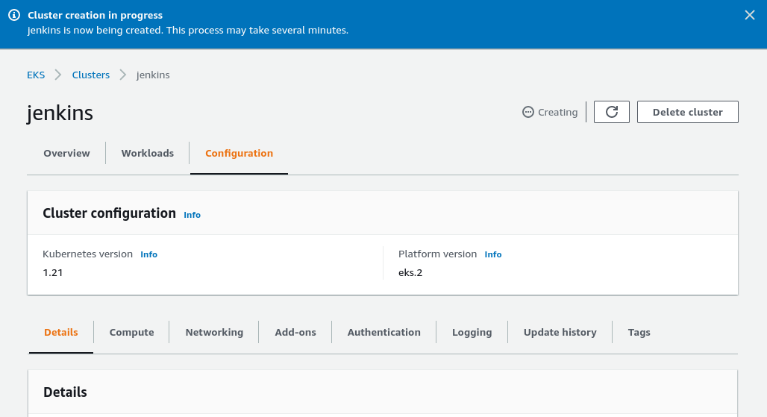

* It will take several minutes to create and then you have to add node group to your eks